Opengl Volcano Coursework
Controls:
WASD to move
Space to go up, shift to go down
Mouse to look around
P to switch between “day” and “night” scenes
1 to enable/disable blur effect

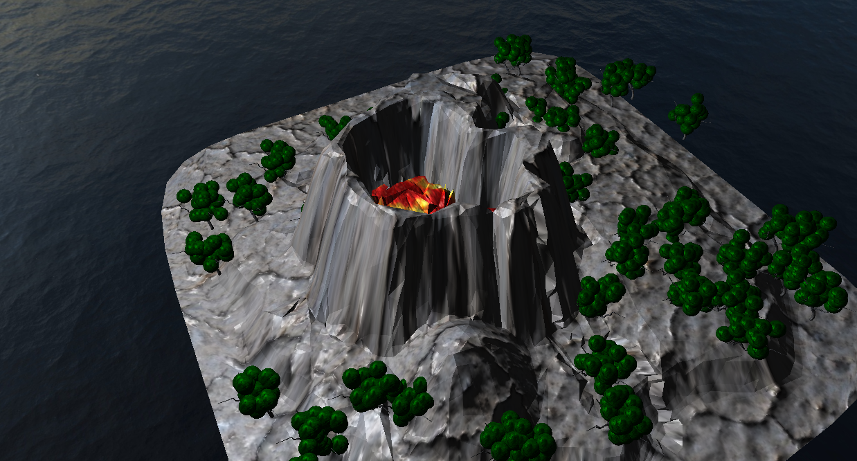
The volcano during day. There are green trees with leaves and the lava level is low. Each tree is randomly placed on the terrain.
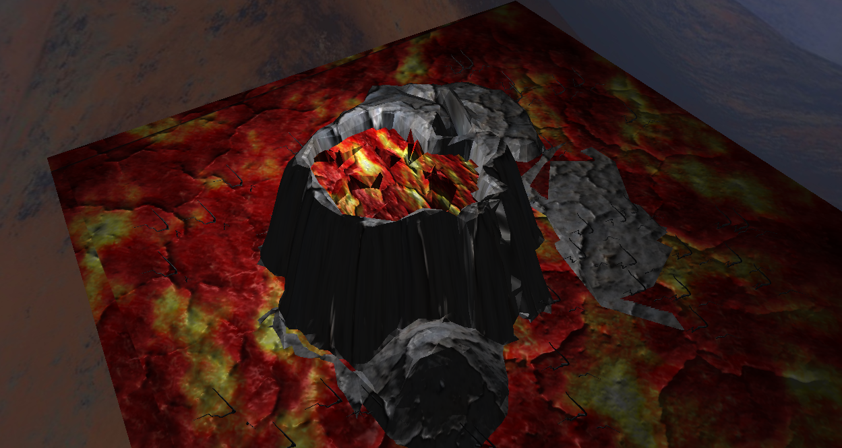
The volcano at night. The lava level inside the volcano is much higher having erupted. The only light is from the volcano itself and all the trees have been charred away.

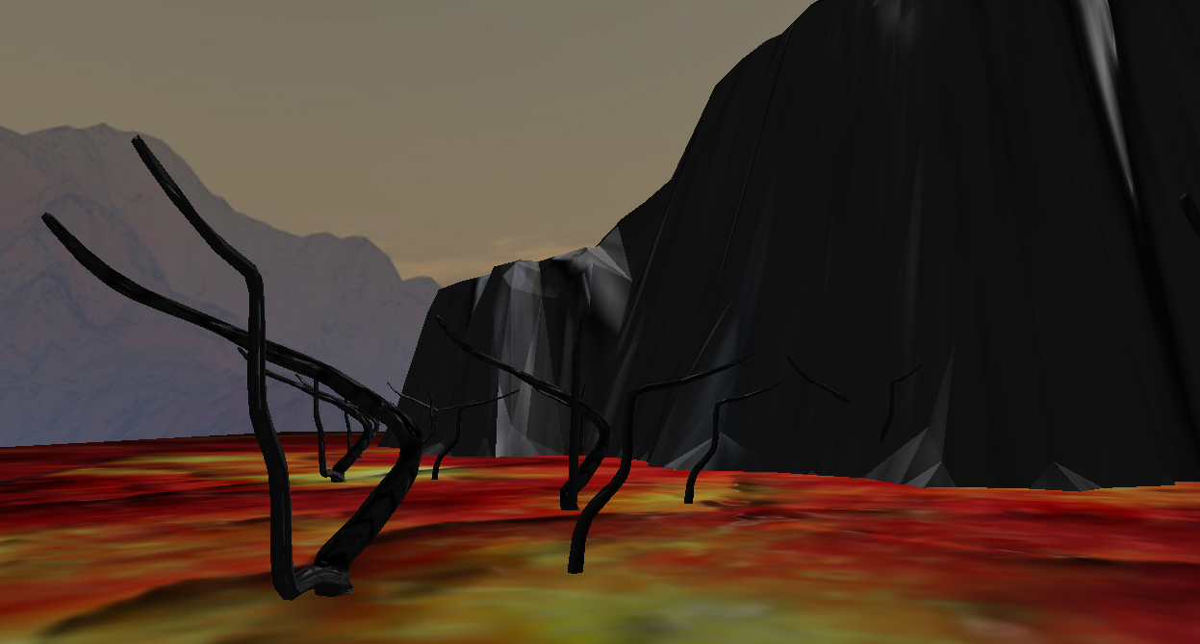
A close up of the trees which have all perished in the lava, leaving only resilient charred trunks and branches. While it cannot be conveyed through a screenshot, the lava swirls around. Since it is night, the lighting is also darker.

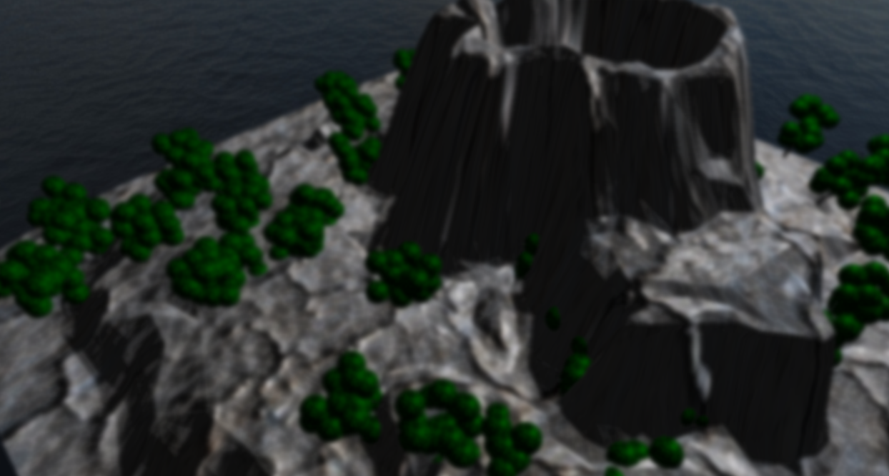
The volcano at day, but with a post processing effect turned on, blurring the view. This is taken from the side facing away from the sunlight.

Mesh/Texture Sources:
Volcano and Tree branch meshes:
https://sketchfab.com/3d-models/the-volcano-8ca14d37f7144b03bd8bdbb8b3c8a455

Lava texture:
https://www.artstation.com/artwork/ybAxA5

Wood texture:
https://www.vecteezy.com/photo/14840967-burned-wood-texture-background-black-burnt-wood-surface

